**AWS CONNECT ADMIN DASHBOARD**

**Operations Manual**

**Index**

1. Log In to the system.
2. UI Description.
3. Administrative Operations -
   1. Campaigns.
   2. Create Campaign.
   3. Agent Provision.
   4. Agent Distribution.
   5. Inbound Number Provision.
   6. Reports -
      1. Agent Wise Report.
      2. Campaign Wise Report.
4. Agent Operation -
   1. Campaign Self Assignment.
   2. Reports -
      1. Agent Dashboard Summary.
      2. Agent Dashboard Call Detail.
5. Common Operations -
   1. Change Password.
   2. Logging Out from the system.

**1. Log In**

Visiting the site URL in a browser, the following screen will appear to the user to login into the system. The user must provide a valid username and password and hit the “Log In” button to get access. Entering invalid credentials will prompt the user with an alert.

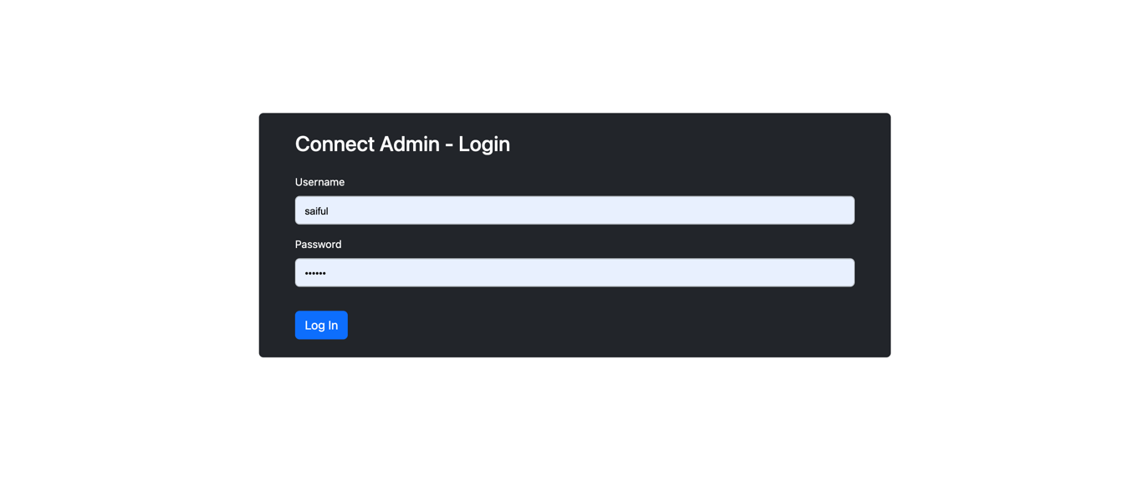­

**2. UI Description**

After successful Sign In, a user will be presented with the following UI. The UI is split into two functional areas. On the left, there is a navigation menu bar with various menus. Clicking on a menu item will direct a user to a page where the feature UI of the description mentioned on the clicked menu will be visible on the right-side pane. Users will also find some contextual action item Buttons on the right side of the pane's title. The logged-in user's name will be visible beside the Log out menu option of the sidebar.

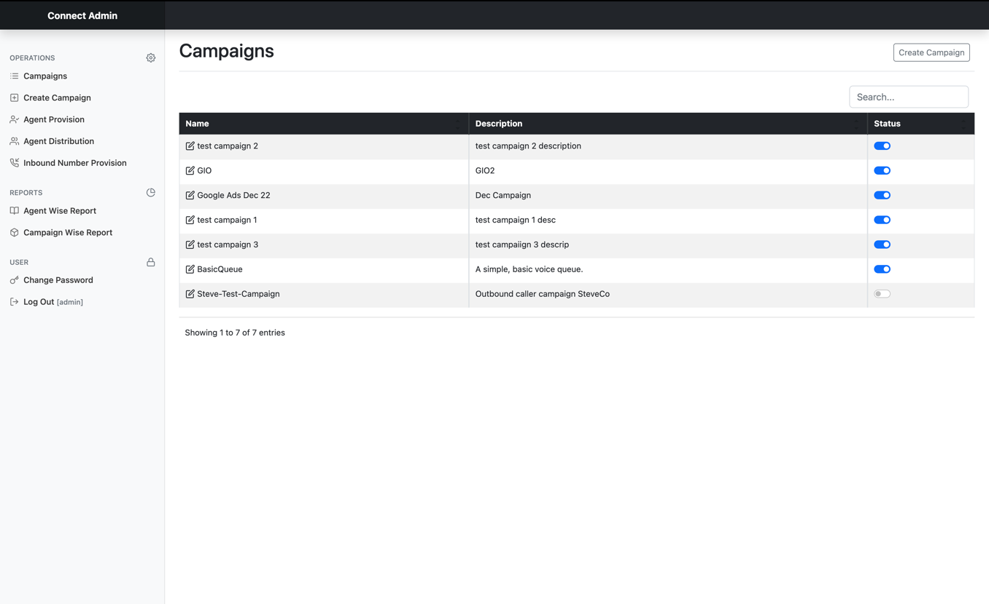

**NOTE**: Items of this UI are only accessible to a logged-in user. Menu items are restricted and will be accessible to users by their role or type (i.e., Administrative and Agent user).

**3. Administrative Operations**

A logged-in Admin user can perform the following action and view some reports. These actions or reports can be chosen from the Side menu.

Administrative Operations:

1. Campaigns
2. Create Campaign
3. Agent Provision
4. Agent Distribution
5. Inbound Number Provision
6. Reports
   1. Agent Wise Report
   2. Campaign Wise Report

These operations and reports are not available to an Agent. Details of these operations are given in the following sections.

**3.1 Campaigns**

A table of existing campaigns, their description, and their status will be visible on this page. Admin users can Activate or Deactivate campaigns by a Switch on the Status column adjacent to the Campaign name in the row. An activated switch will be visible as **Blue** in color and **Grey** when not activated. They can also search for a specific campaign from the search bar on the campaign list.



**NOTE**: The limit of the AWS Connect instance constrains the maximum number of campaigns created by this application. A campaign in this application is translated as a queue in AWS Connect.

**3.2 Create Campaign**

To create a new Campaign, an Admin user will click Create Campaign menu item from the sidebar, and the following page will appear with a form to enter campaign details. Here, the name of the campaign must be a unique value (i.e., not used earlier). An outbound phone number and hours of operation need to be selected from the provided dropdown. Although the campaign description field is optional, the user should enter a short campaign description for ease of further identification.

After hitting the “Create” button, the user will receive a notification about the status of the campaign creation. If the full quota of the campaign an AWS Connect instance provides is used, no other campaigns can be created, and the user will be notified with a message - "Campaign/Queue creation Limit Exceeded."

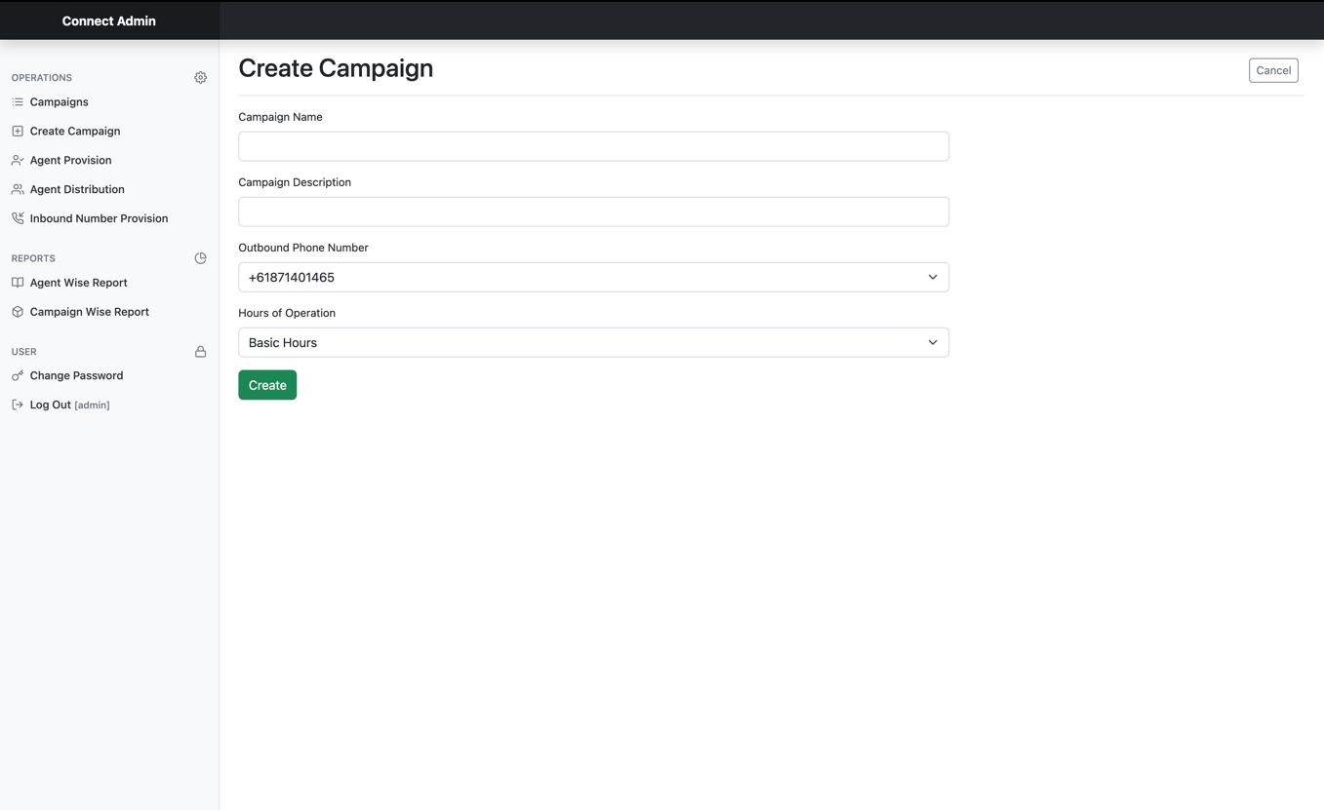

**3.3 Agent Provision**

Before enabling an Agent user to use the system, s/he must be provisioned through this application. Admin users will click the Agent Provision menu from the sidebar and be presented with a page with two sections. On the left is a selectable Un-provisioned agent list; on the right, there will be a list of already provisioned agents. Both of these lists are searchable for ease of the Admin.

Admin can select one or more un-provisioned agents from the selectable list on the left and hit the “Provision Selected Agents” button.

While the provisioning operation is being executed, the admin will see a spinner indicating that some background job is being performed. After completion, he will receive a notification of the result of this operation. Please note that the provisioned agents cannot be un-provisioned from this application, and users created by AWS consoles are only available on this page. Already provisioned agents will not be visible on the un-provisioned agent list.

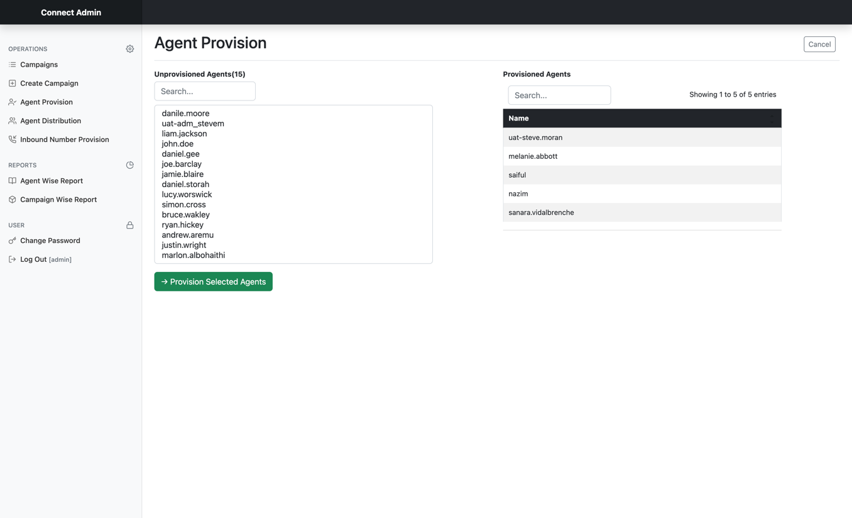

**3.4 Agent Distribution**

An agent can be assigned or removed to one or more campaigns. An Admin will click on the Agent Distribution menu from the sidebar to perform this. The admin will see three selectable and searchable lists on the designated UI: Campaigns, Mapped Agents, and All agents. There are three buttons to add or remove an agent from a campaign and save the changes.

When a Campaign is selected by clicking on it from the Campaign list box, existing assigned or mapped agents will appear in the Mapped Agents section. Mapped agents can be selected and removed by pressing the “->Rem” button. Unmapped agents can be chosen from the All-Agents list box and added to a campaign by pressing the “<-Add” button. In both cases, a campaign must remain fixed, and to save the changes, Admin must press the “√ Save” button. After completion of the process, the admin will receive a notification message of the status of the operation.

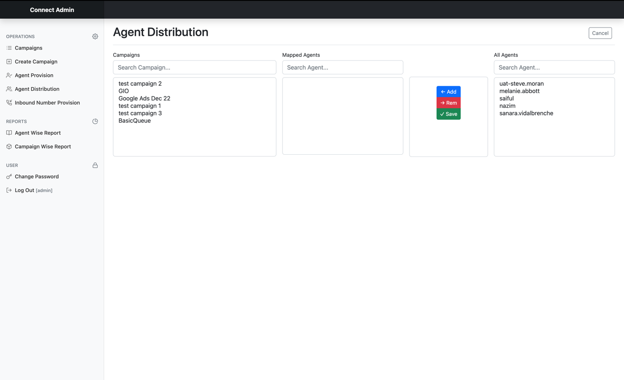

**3.5 Inbound Number Provision**

Admins can set, unset, or change Inbound Number to a campaign. This operation can be performed by selecting the Inbound Number Provision menu from the sidebar. This will show a UI with three list boxes: Phone Number, Mapped Campaign, and All Campaigns. There are also three buttons to provision a number and save the changes. Phone Number and All Campaigns lists are searchable. Phone numbers are visible along with their set description. Clicking on a Phone number will show the associated campaign in the Mapped Campaign box, which can be removed by selecting it and pressing the “->Rem” button.

Similarly, a campaign can be selected from the All-Campaign box, and the “<-Add” button will add it to the Mapped Campaign box. If a campaign is already mapped, it must be removed before adding a new one. Changes will only persist after pressing the “√ Save” button, and the admin will be notified with a status after completing the process.

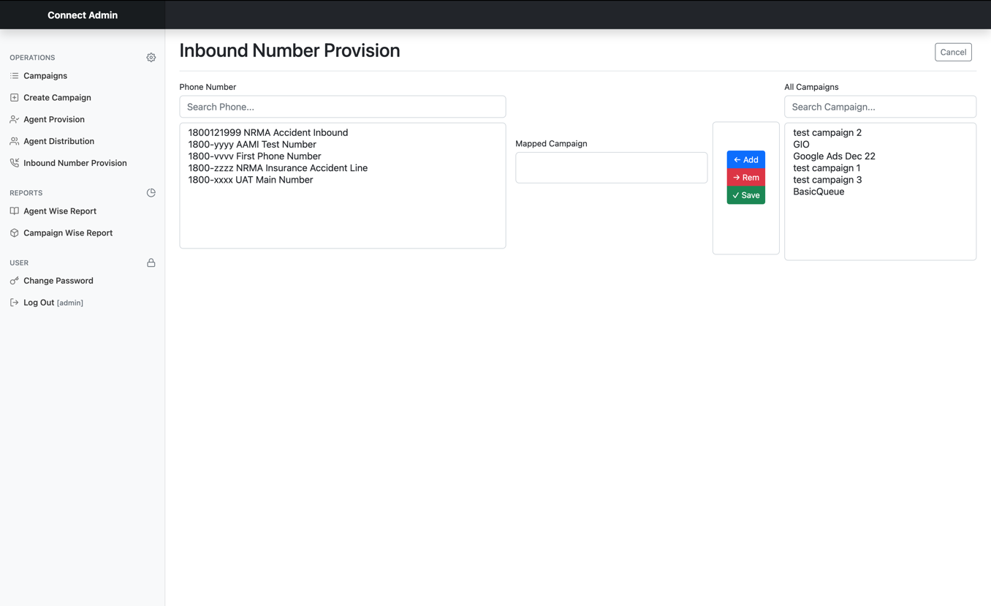

**3.6 Reports**

The following two Reports are available to a Contact Center Manager or Admin User –

1. Agent Wise Report
2. Campaign Wise Report

**3.6.1 Agent Wise Report**

This report shows every agent’s activity aggregated by Agent’s Name, Call direction, and Campaign Name. The following three metrics are available –

1. Total Call
2. Total Talk Time
3. Avg. Talk Time

The report is filtered to show the activity of the present working day in the Sydney Time zone (UTC +11), starting from zero hours (midnight) to the time of the view. It updates every 20 minutes. Admin can view this by clicking on the Agent Wise Report menu item on the sidebar.

For further analysis, reporting, or other necessities, the report can be exported in different formats like CSV, Excel, and PDF. It can also be printed. It has options for searching and limiting the number of visible rows.

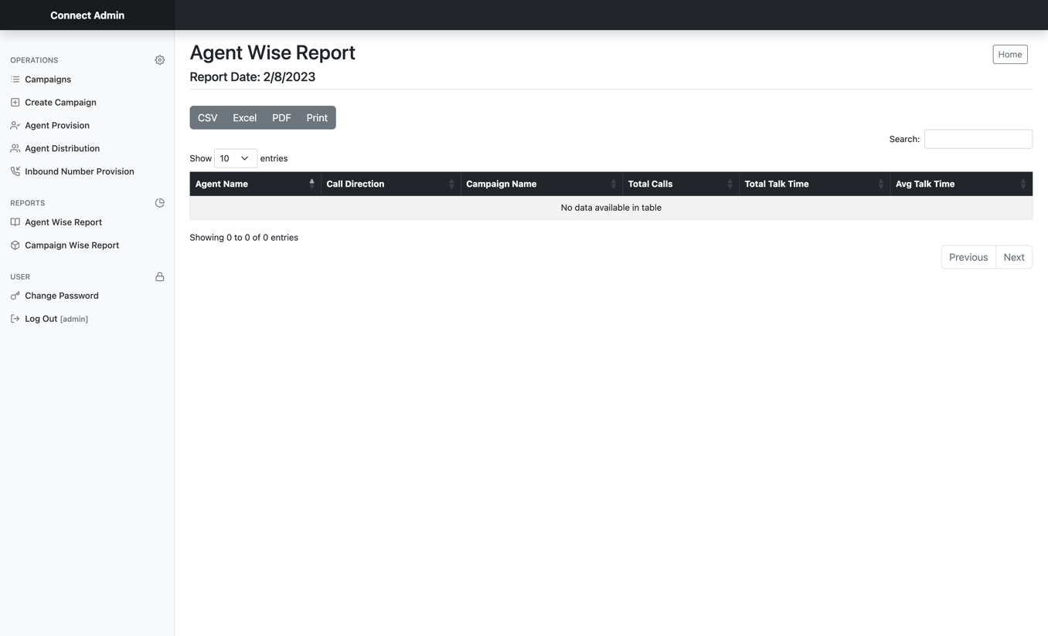

**3.6.2 Campaign Wise Report**

Featuring all the options for exporting, printing, and filtering, this admin report shows the following metrics, which are aggregated by “Inbound Group” –

1. Calls
2. Connects
3. Disconnects
4. Disconnect Rate
5. Talk Time
6. Avg. Talk Time
7. Wait Time
8. Avg. Wait Time
9. Longest Wait Time

Admins can access this by clicking on the Campaign Wise Report menu item from the sidebar.

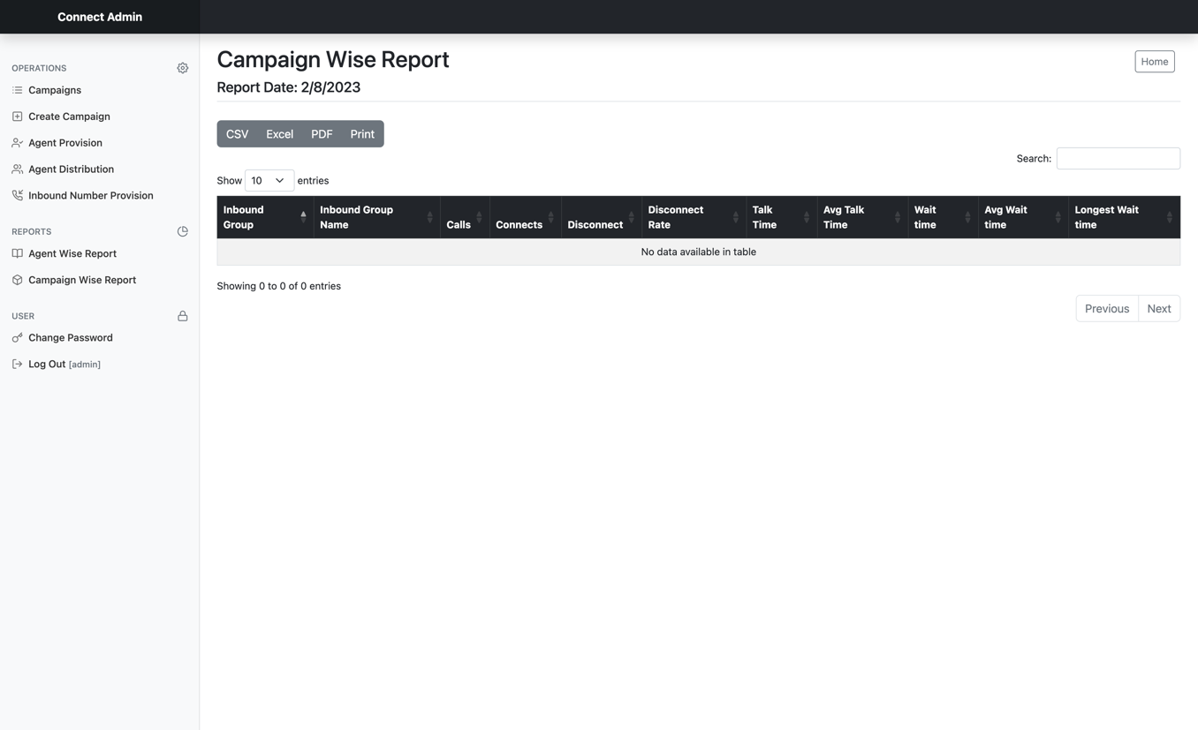

**4. Agent Operation**

An Agent can perform some operations and view reports from his panel as below –

1. Campaign Self Assignment.
2. Reports -
   1. Agent Dashboard Summary.
   2. Agent Dashboard Call Detail.

These items are not available to an Admin User.

**4.1 Campaign Self Assignment**

This option is accessible to an agent and can be activated by clicking the Assign Campaign menu item. Here, agents can assign or remove themselves from campaigns. Two searchable and selectable list boxes are available on this page – Assigned Campaigns and All Campaigns, along with buttons to assign, remove and save the changes.

Agents can select an already assigned campaign from the Assigned Campaigns box and remove it by hitting the “->Rem” button. They can assign a new campaign to themselves by selecting a campaign from the ‘All Campaigns’ box and pressing the “<-Add” button. Changes will be saved after hitting the “√ Save” button.

Please note that only one change can be made here at a time.

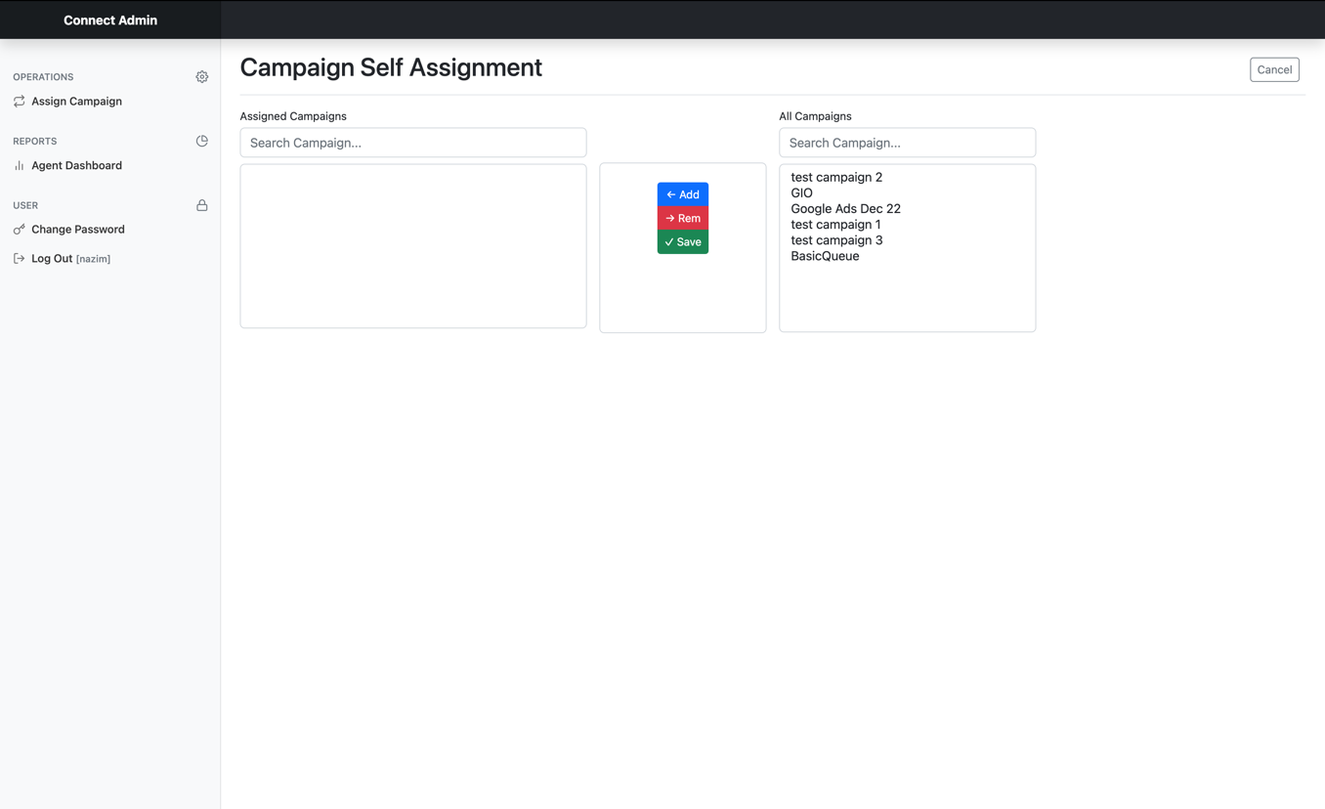

**4.2 Reports**

Following Reports are available to an agent in the Agent Dashboard in two Tabs –

1. Agent Dashboard Summary.
2. Agent Dashboard Call Detail.

**4.2.1 Agent Dashboard Summary**

In this report, agents will see the metrics below –

1. Talk Time
2. Wait Time
3. Wrap Time
4. Calls

It will be summarized for a day in the Sydney Time zone (UTC +11), starting from midnight until the time of viewing the report. It refreshes every 20 minutes.

An agent can access this in the Summary Tab of the Agent Dashboard page, which will appear after clicking The Agent Dashboard menu item on the sidebar.

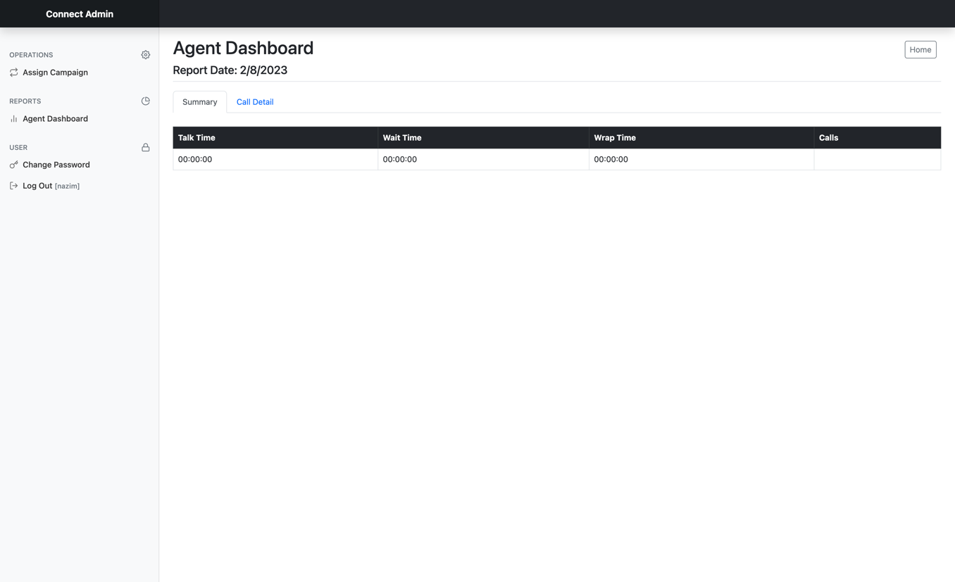

**4.2.2 Agent Dashboard Call Detail**

Like the previous report, this report is filtered for the same time frame and time zone. Here, an agent can view all handled calls by themself. It can be viewed in the Call Detail Tab of the Agent Dashboard by clicking the Agent Dashboard item of the sidebar.

The following metrics are available in this report –

1. Date Time
2. Customer Number
3. Call Direction
4. Campaign Name
5. Campaign Hotline
6. Talk Time
7. Wrap Time
8. Wait Time

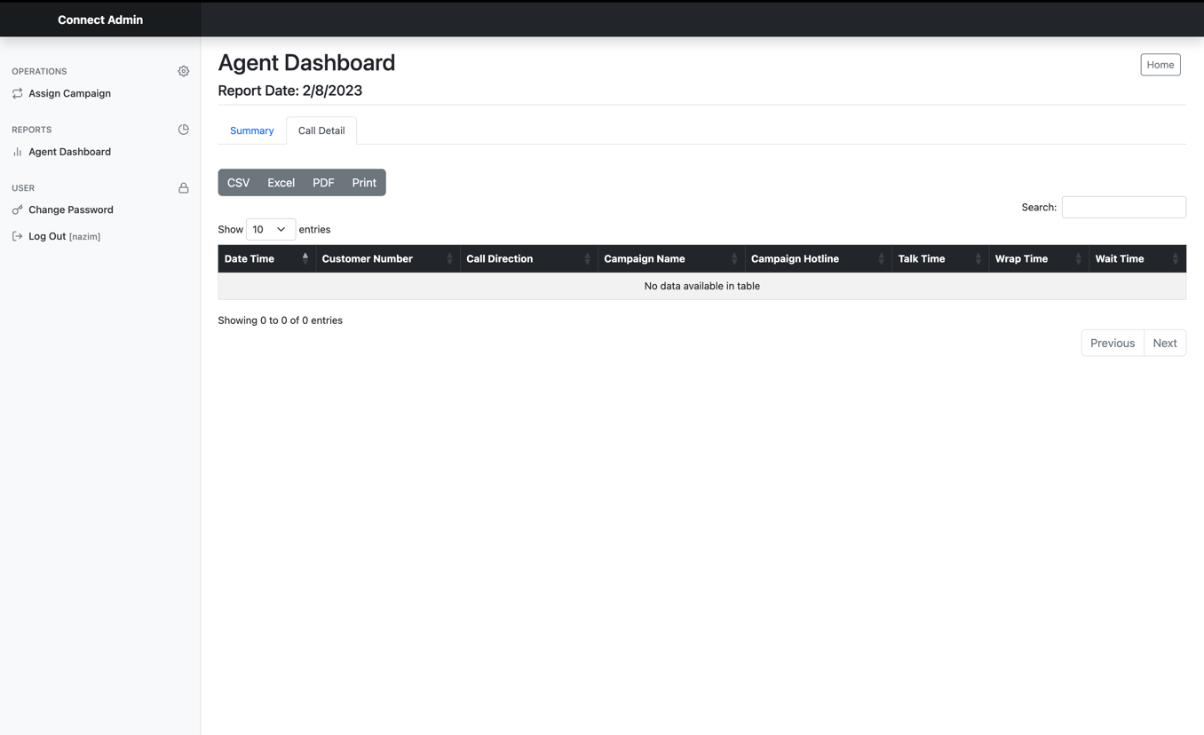

**5. Common Operations**

The following operations are common to Admin and Non-Admin (Agent) users.

**5.1 Change Password**

Users can change their password after logging into the system. They must choose the Change Password menu item from the sidebar. The following rules will be applied to change the password –

1. The password length must be between 4 and 12 (inclusive).
2. The New Password and Verify New Password fields must match.
3. There will be no character restriction.
4. Users have to press the “Save” button to persist the changes.

Users will be notified with a message about the status of the operation.

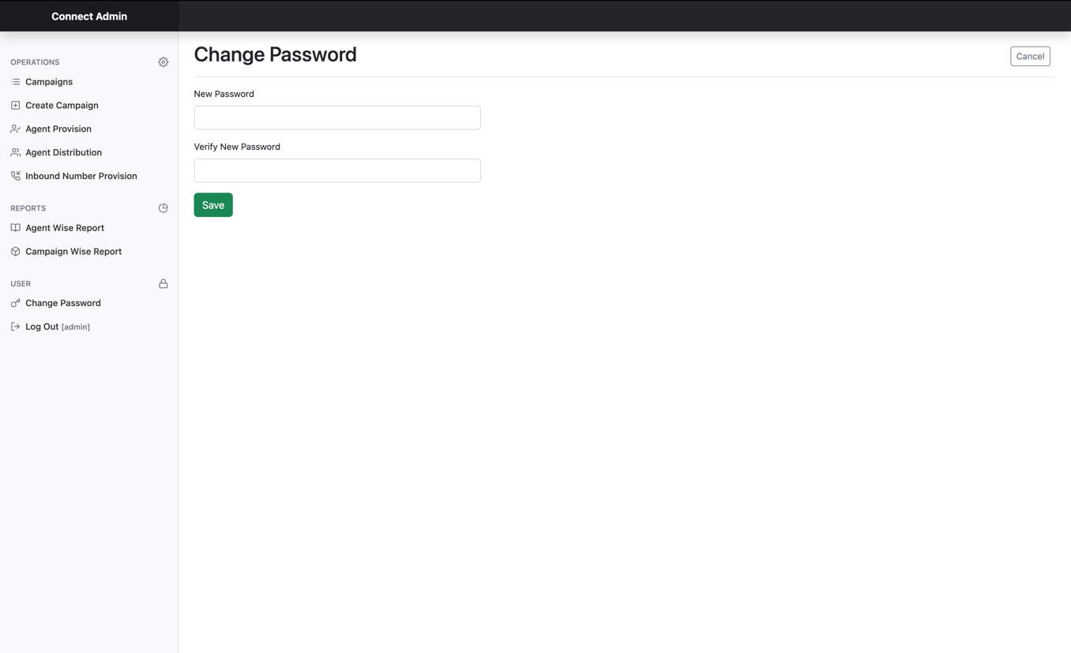

**5.2 Logging Out from the system**

Every logged-in user will get a Log Out menu option in the sidebar. After completing the work, users must Log Out from the system for security purposes.



EOD